**SSM INSTITUTE OF ENGINEERING AND TECHNOLOGY**



**Dindigul- Palani Highway, Dindigul – 624 002**

**NATIONAL SERVICE SCHEME**

**Campus Beautification Campaign - Report**

Beautification Campus promotes Hygiene, It improves hygiene level in campus and also helps to reduce the spread of sickness, maintaining a clean college environment sets a good example to students. Cleanliness encourages learners to take pride in their college, which makes them less likely to drop litter and as such they will potentially make a bigger effort to maintain their environment. Cleanliness gives rise to a good character by keeping body, mind, and soul clean and peaceful. Maintaining cleanliness is the essential part of healthy living because it is the cleanliness only which helps to improve our personality by keeping clean externally and internally.  
The first year of NSS volunteers and interested students gathered to clean the surroundings of the individual buildings in the campus. They enthusiastically collected plastic wastes, tea cups, weeds, and dry leaves spread over the surrounding areas and they gathered all the waste and trash bags to the place where the college arranged for the removal of collected wastes. The whole cleaning drive was quite inspiring and motivating for the NSS team members.

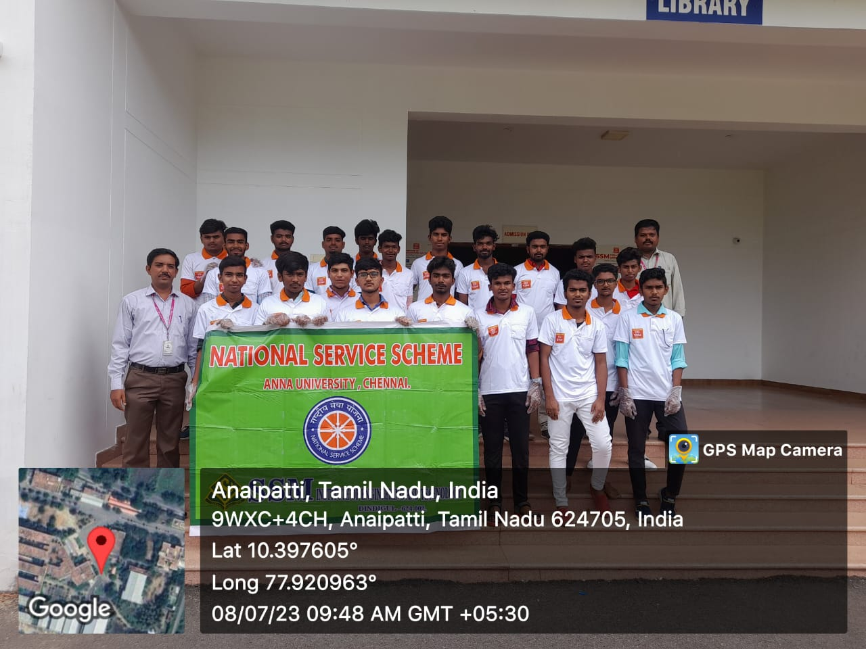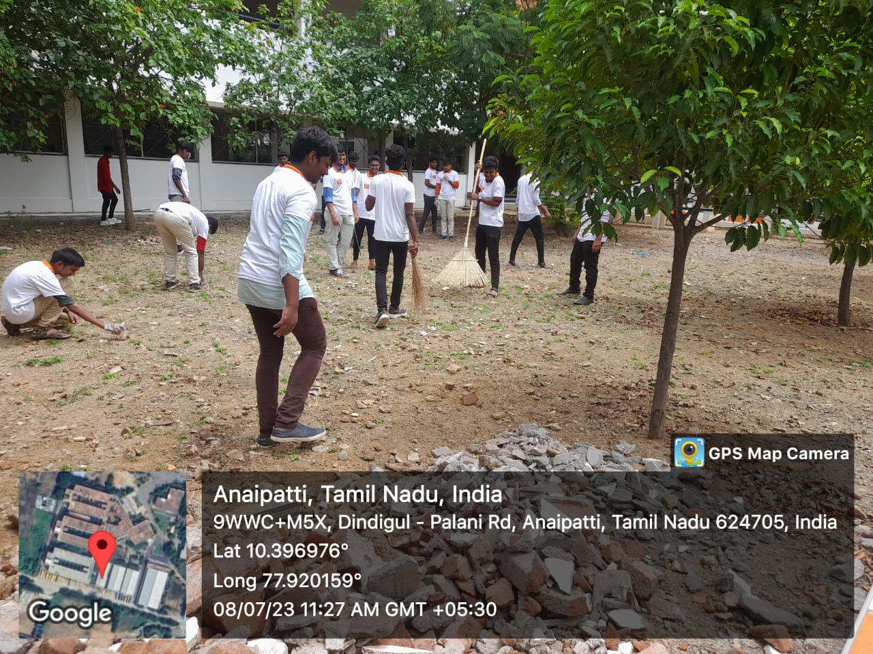

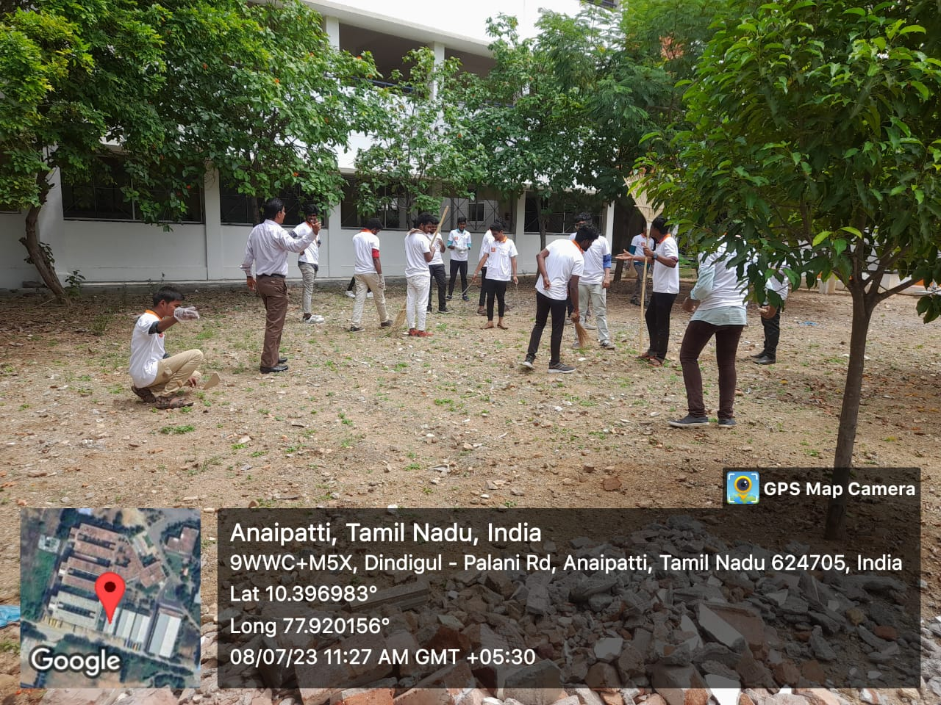

NSS Coordinator Principal

Dr..R.SATHEESH BABU